Practical No:04

Configure IP ACLs to Mitigate Attacks and IPV6 ACLs

Network:
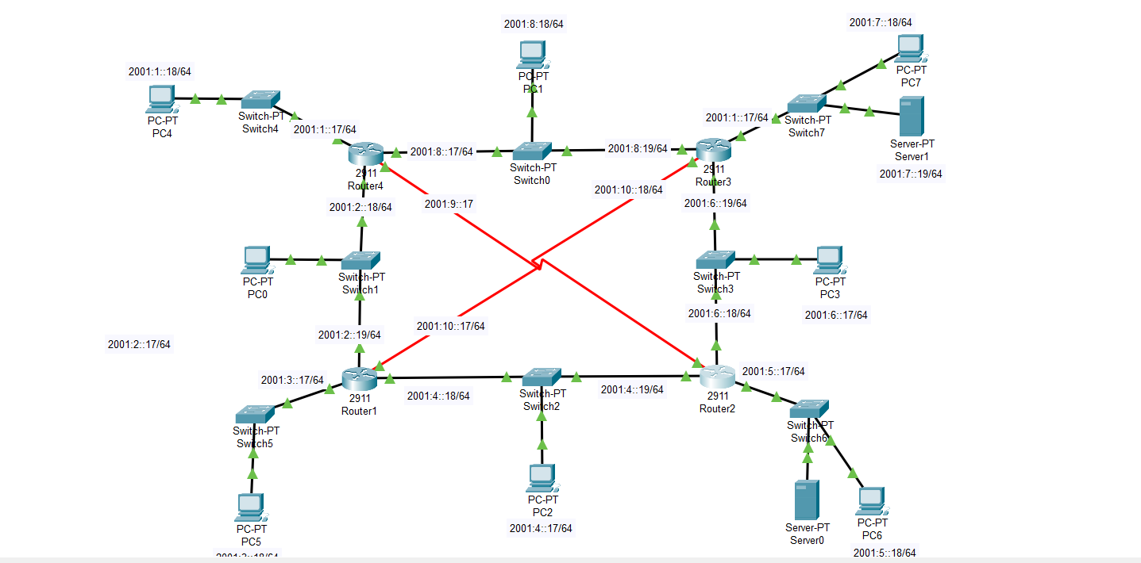

Router Configuration In IPV6

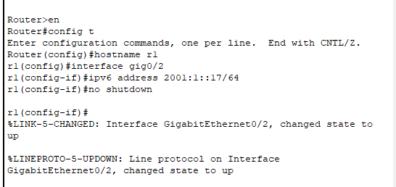

Assing IP to the PC

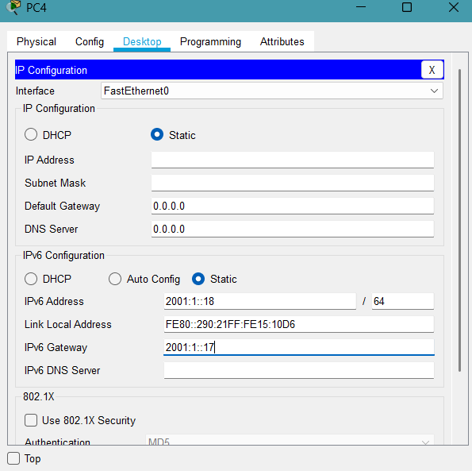

Rip routing for all Router

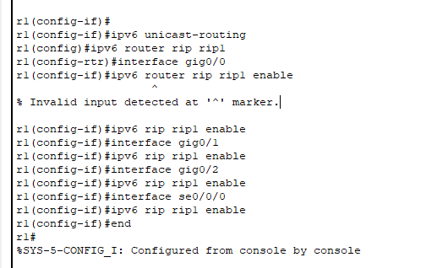

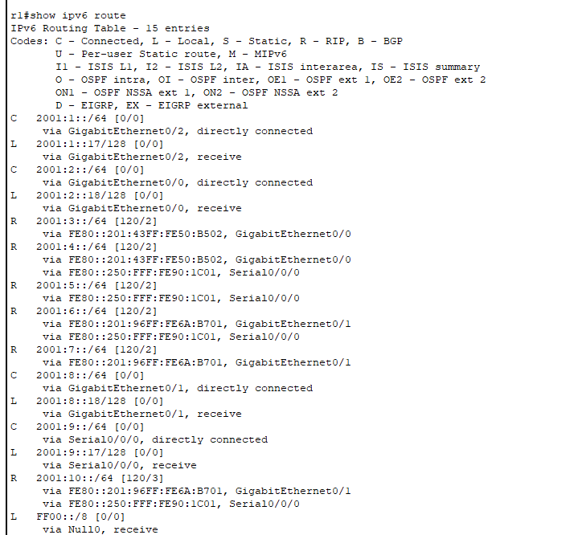

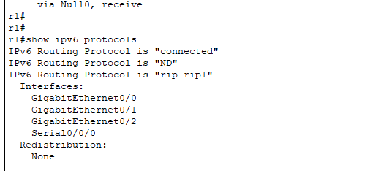

Verify Rip routing
Command for pc

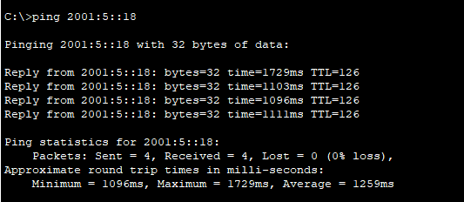

Command For Router

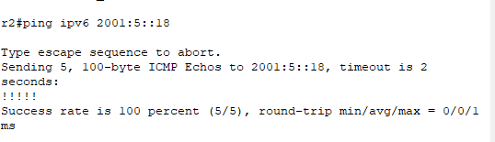
Configure ACLs on to mitigate attacks. Configuring IPv6 ACLs
Source IP- 2001:1::8
Source IP- 2001:2::8
Destination IP-2001:5::19
Destination IP-2001:7::19

In ACL –1)Block HTTP (Port 80)
2)Block FTP (Port 21)
3) Allows all other traffic.

Block Http

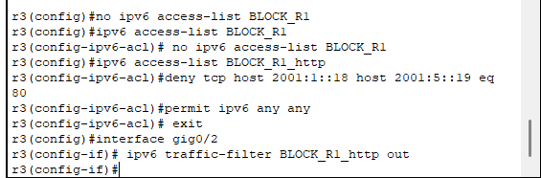

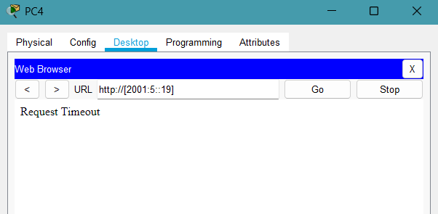

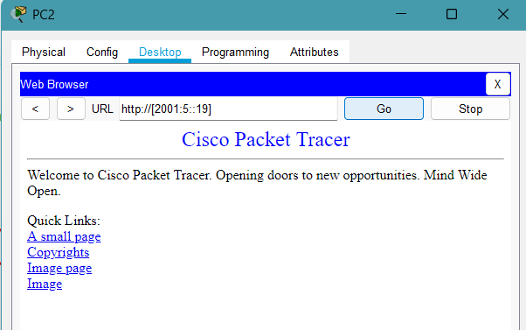s

2)Block FTP

